**Sprint 3-Agility Design Document**

**December 4 2023**

**Authored by: Christopher Buzaid, Zacahry Zucconi, Royce Amburg**

**Table of Contents**

**1. Executive Summary…………………………………………………… 3**

1.1 Project Overview …………………………………………………………… 3

1.2 Purpose and Scope of this Specification ……………………………………. 3

**2. Product/ Service Description…………………………………………. 4**

2.1 Product Context……………………………………………………………... 4

2.2 User Characteristics…………………………………………………………. 4

2.3 Assumptions………………………………………………………………… 4

2.4 Constraints…………………………………………………………………... 4

2.5 Dependencies………………………………………………………………... 5

**3. REQUIREMENTS……………………………………………………. 5**

3.1 Functional Requirements……………………………………………………. 5

3.2 Security……………………………………………………………………… 6

3.2.1 Protection………………………………………………………………….. 6

3.2.2 Authorization and Authentication…………………………………………. 6

3.3 Portability……………………………………………………………………. 7

**4. Requirements Confirmation/Stakeholder Sign-Off……………….. 7**

**5. SYSTEM DESIGN…………………………………………………… 7**

5.1 Algorithm……………………………………………………………………. 7

5.2 System Flow………………………………………………………………… 8

5.3 Software……………………………………………………………………... 9

5.4 Hardware…………………………………………………………………….. 9

5.5 Test Plan……………………………………………………………………..9

5.6 Task List/Gantt Chart………………………………………………………..12

5.7 Staffing Plan…………………………………………………………………12

**1. Executive Summary**

**1.1 Project Overview**

* The Sprint 3 Agility project is one part of a three part project that aims to develop and code a Sphero Bolt robot to successfully complete multiple sprint courses in our classroom, HH 208. The Third Sprint,Agility, aims to have the robot complete an obstacle course. The robot will start in a square and has to avoid 3 objects when completing the course. The robot must also drive over a ramp and hit into a set of pins with each pin getting knocked down adding a point to our final score. This project is suitable for educational purposes, STEM programs, and robotic enthusiasts.

**1.2 Purpose and Scope of this Specification**

The purpose of this specification is to describe our groups completion of the third sprint, Agility, in our robotics project, including our requirements, code, constraints and overall success of our third Sprint . The intended audience of this program is Dr. Eckert, and the other groups to compare how our robots made it across the course.

In scope:

* The group will build a fully functional robot program to perform a “figure 8 course” by the due date of Sprint 2: Accuracy.
* All group members will work on this document and the code for Sprint 3- Agility. The date of completion will be before 12/04/23, at 11:59 PM
* The group will build a fully functional robot program to avoid 3 obstacles on an obstacle course through the classroom by the due date of Sprint 3: Agility.
* Group will complete a presentation on our robot code and triathlon by: (December 5th, 2023 1:00 PM)

Out of scope:

* The group will build a fully functional robot that is able to travel around the periphery of room HH 208 and speak. ***Completed***
* All group members will work on the document and code for Sprint 1- Endurance. The date of completion will be before 11/7/23, at 11:59 PM ***Completed***
* The group will build a fully functional robot program to perform a “figure 8 course” by the due date of Sprint 2: Accuracy. ***Completed***
* All group members will work on this document and the code for Sprint 2- Accuracy. The date of completion will be before 11/20/23, at 11:59 PM ***Completed***

**2. Product/ Service Description**

The product is a sphere that is able to roll and spin in any direction that is controlled via user input from block code in the Sphero Edu application. Its environment that the robot is in, is a classroom with blue tape on the ground to mark its path with obstacles like desks and chairs making the margin for error slim. The robot can “talk” through the speakers of a computer and it moves using a motor that shifts its weight towards a specific direction. The robot even emits colored lights that can be changed using the block code.

**2.1 Product Context**

This product relates to the famous automobiles we all drive. They both require user input in order to move. The robot is unable to move on its own, and requires the user to input, block code, in order for it to move. This is much like how a car can not drive itself, and require the user (aka. the driver) to start the engine using a key, use the gas pedals, and steering wheel, in order to make it move.

**2.2 User Characteristics**

* Users of this project may include students, educators, and robotics enthusiasts with varying levels of experience and technical expertise. Participants are expected to possess basic programming knowledge and be able to control the robot using compatible devices.
  + Student- Possess a basic understanding of programming concepts and robotics. Are actively interested in studying computer science or robotics and are eager to learn more of the subject.
  + Educator- A teacher or professor in the field of computer science or robotics who fully understands robotics and has years of experience in the field and will use the product as a tool for teaching their students.
  + Robotics Enthusiasts- Passionate about robotics and have a varying range of experience levels that may come from DIY robotic projects.

**2.3 Assumptions**

The equipment is not always available due to only one of us having access to the robot. We also all have different schedules making it challenging to find times to work together on the project. User expertise is a factor as well due to some of us having more background experience with coding than others. The Sphero operating system is constantly available as it is a program on our devices,however the Sphero robot itself is not constantly available.

**2.4 Constraints**

* Room Availability - HH room 208 isn't always available as classes and lectures occur there multiple times every day. The group must find windows throughout the day to go to the room.
* Classmates Availability - The group must find windows throughout the day to meet to work on the project that best works with everyone's schedule.
* System constraints could include a device such as a laptop not having access to download the Sphero Edu application.
* The use of block code may be a constraint as some members may not have experience in the use of block coding.

**2.5 Dependencies**

* Having the programed functional robot is a dependency
* The course needs to be set up before we can execute the requirements. (Yellow Square, Blue tape, Obstacles etc)
* In order to connect to the robot you must download the Sphero Edu application onto your device.

**3. Requirements**

***3.1 Functional Requirements***

| **Req#** | **Requirement** | **Comments** | **Priority** | **Date Reviewed** | **SME Reviewed / Approved** |
| --- | --- | --- | --- | --- | --- |
| **AGIL-01** | System must successfully complete the obstacle course | The robot has to make it through the obstacle course to be considered successful | 1 | 12/1/2023 | 12/3/2023  Approved |
| **AGIL-02** | The system must run the obstacle course while avoiding the obstacles along the course | If the robot hits any obstacles, then points will be deducted from the project, so we have to avoid that | 1 | 12/1/2023 | 12/3/2023  Approved |
| **AGIL03** | System must start in the middle of the square at the start of the obstacle course | This is where the robot must be placed to properly begin the trial | 1 | 12/1/2023 | 12/3/2023  Approved |
| **AGIL-04** | System must drive into and topple as many pins as possible | There will be points added for each pin toppled. Robot needs to pick up speed and topple as many as possible. | 1 | 12/1/2023 | 12/3/2023  Approved |
| **AGIL-05** | System must be able to drive over a ramp | Robot must have enough speed to be able to make it over ramp and continue the course | 1 | 12/1/2023 | 12/3/2023  Approved |
| **AGIL-06** | System must have representative sensor data after the completion of the agility course | Must be completed to show the path of the obstacle course that was ran by the robot | 1 | 12/1/2023 | 12/3/2023  Approved |

***3.2 Security***

**3.2.1 Protection**

* Only one person has access to the robot at a time as the robot can only connect to one device/system at a time.
* The robot has a unique name that allows easy connection and helps prevent a user from connecting to another group's robot.
* A user cannot gain access to the robot if they do not have the authorized credentials, i.e. not a group member working on the project
* A user does not have the ability to view or modify the robots source code
* The robot does not have the ability to run without an authorized users connection to the robot via the Sphero Edu application

**3.2.2 Authorization and Authentication**

* The Robot will request the user to verify who they are by providing the correct credentials forcing them to authenticate themselves to the system.
* An Administrative user is able to grant users with specific permissions to the robot. Internal users will have access to make modifications to the robot. End users will have access to connect to the robot and run the system
* When a user authenticates themselves successfully we will ask for the users email or phone number and store their device information. When a preexisting user authenticates to the system, we give them the ability to sign in with a one time passcode instead of their username and password.

**3.3 Portability**

The Sphero robot has high portability potential. The robot itself is very small, able to fit in your hand and comes in a carrying case that has the ability to hold the robot and the charger. It is also very easy to obtain access to the Sphero Edu as it can be downloaded off of the Sphero website onto a smartphone, laptop, and pretty much any device, as long as the device has bluetooth capabilities. You can run it with many OS systems, such as Windows, and Apple, so the type of device you are using does not matter.

**4.**

| **Meeting Date** | **Attendees (name and role)** | **Comments** |
| --- | --- | --- |
| **12/2/2023** | **Chris Buzaid(Block code, System Design Document), Zachary Zucconi(System Design Document)** | **Confirmed all except AGIL-02, AGIL-05d** |
| **12/3/2023** | **Chris Buzaid(Block code, System Design Document) , Royce Amburg(System Design Document)** | **Confirmed all except AGIL-05** |
| **12/4/2023** | **Chris Buzaid(Block code, System Design Document)** | **Confirmed all *- Chris Buzaid*** |

All requirements were met for Sprint 3-Agility- *Chris Buzaid, Royce Amburg, Zachary Zucconi*

**5. System Design**

**5.1 Algorithm**

Step 1: Place robot at starting location: The square at the beginning of the obstacle course

Step 2: Use bock code to make robot move to the end of the first line, avoiding the obstacle

Step 3: Use block code to make the robot turn and move to the end of the second line, avoiding the obstacle

Step 4: Use block code to make the robot turn and move to the end of the third line, avoiding the obstacle

Step 5: Use block code to make the robot turn at the end of the third line

Step 6: Use block code to make the robot speed up and drive over the ramp along the 4th line

Step 7: Use block code to have the robot stop and turn at the end of the 4th line

Step 8: Use block code to have speed up and collide with the pins at the end of the 5th line (Dry erase markers)

**5.2 System Flow**

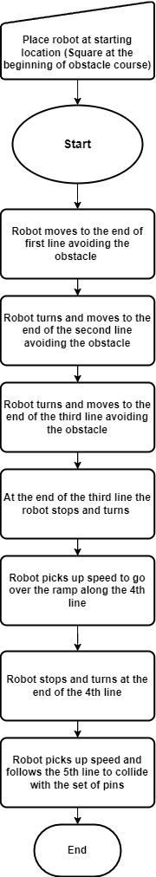

**5.3 Software**

* The software used to code the Sphero Robot was block code that was constructed in the Sphero Edu application.

**Code and sensor data is pictured below**

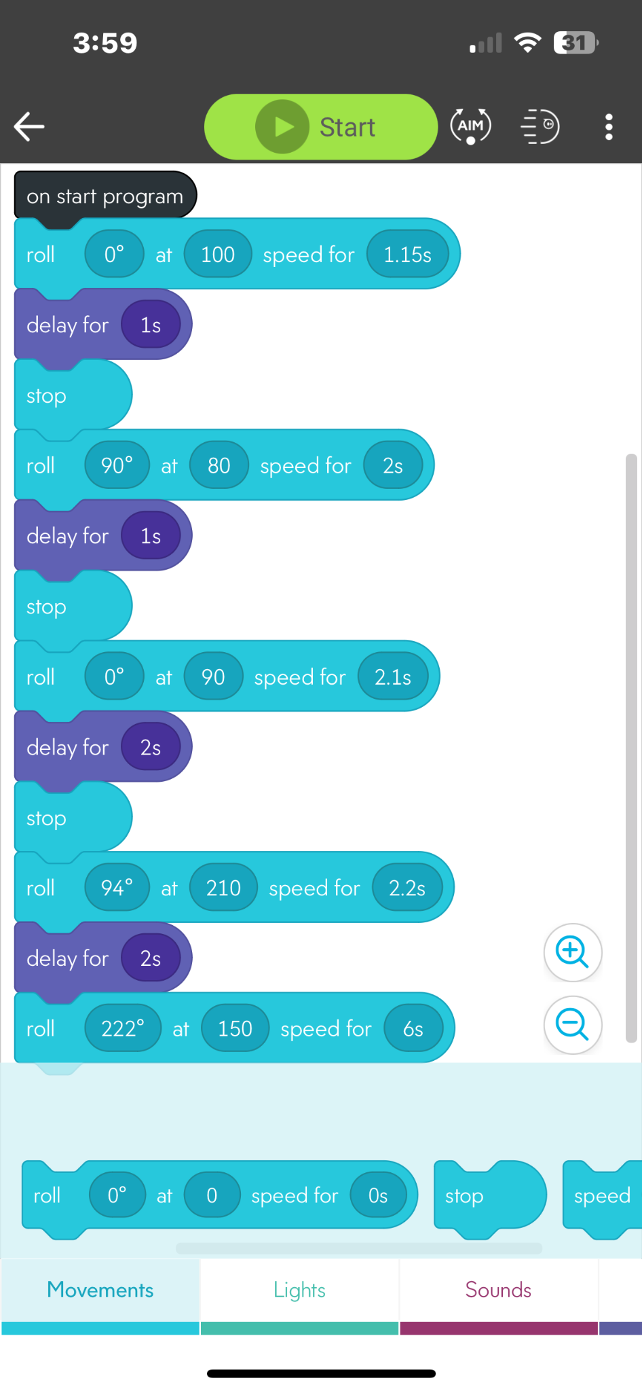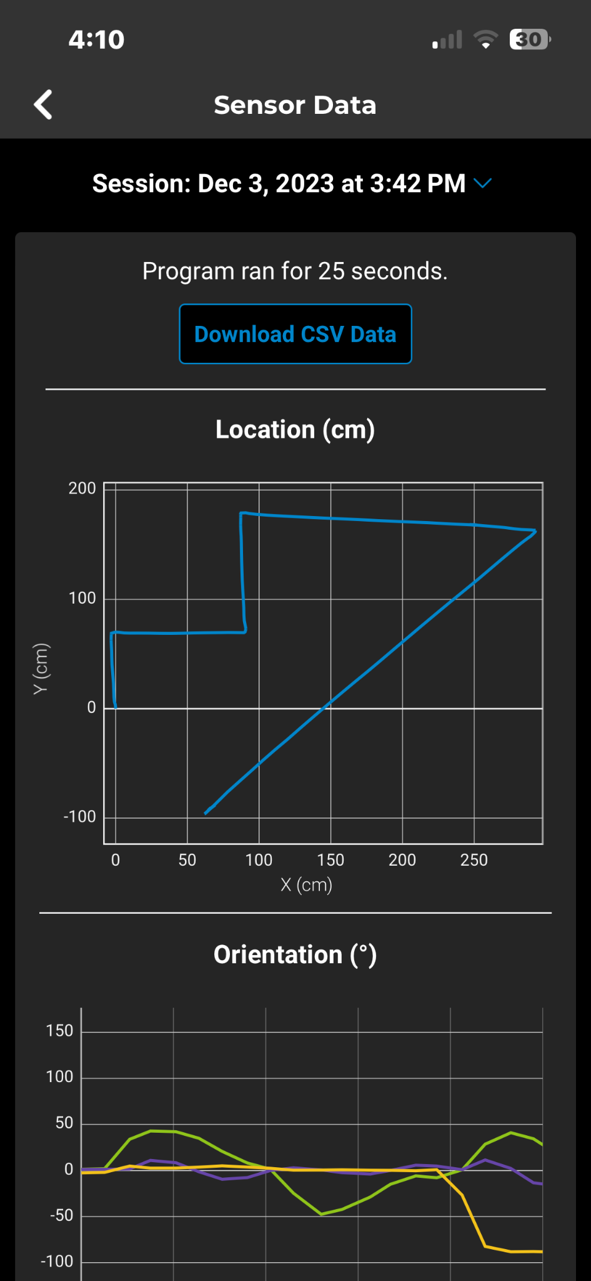

**5.4 Hardware**

* Sphero Edu application on a Windows Lenovo laptop, to develop, build, and test the code.
* An Apple Iphone was used to record the video and also to analyze the sensor data provided by the Sphero robot.

## **5.5 Test Plan**

| Reason for Test Case | Test Date | Expected Output | Observed Output | Staff Name | Pass/Fail |
| --- | --- | --- | --- | --- | --- |
| To make the robot move to the end of the first line without hitting an obstacle | 12/2/2023 | The robot would move to the end of the first line without colliding with the obstacle on the course | The robot successfully moved to the end of the first line without hitting the obstacle | Chris Buzaid | Pass |
| To make the robot turn and move to the end of the second line without hitting an obstacle | 12/2/2023 | The robot would turn and move to the end of the second line without colliding with the obstacle on the course | The robot successfully turned onto the second line however collided with the obstacle that was on the second line | Chris Buzaid | Fail |
| To make the robot turn and move to the end of the second line without hitting an obstacle | 12/2/2023 | The robot would turn and move to the end of the second line without colliding with the obstacle on the course | The robot successful turned and moved to the end of the second line without colliding with an obstacle | Chris Buzaid | Pass |
| To make the robot turn and move to the end of the third line without hitting an obstacle | 12/2/2023 | The robot would turn and move to the end of the third line without colliding with the obstacle on the course | The robot successfully turned however collided with the obstacle along the third line of the course | Chris  Buzaid | Fail |
| To make the robot turn and move to the end of the third line without hitting an obstacle | 12/2/2023 | The robot would turn and move to the end of the third line without colliding with the obstacle on the course | The robot changed direction but it changed direction to late causing it to be off the path of the second circle | Chris Buzaid | Pass |
| To make the robot turn and pick up enough speed to go over the ramp along line 4 and stop at the end of line 4 | 12/3/2023 | The robot would successfully turn, pick up speed and go over the ramp along the 4th line and stop at the end of the line | The Sphero robot successfully turned however did not follow the path of the 4th line causing it to miss the ramp | Chris Buzaid | Fail |
| To make the robot turn and pick up enough speed to go over the ramp along line 4 and stop at the end of line 4 | 12/3/2023 | The robot would successfully turn, pick up speed and go over the ramp along the 4th line and stop at the end of the line | The robot successfully turned and followed the path of line 4 but did not have enough speed to make it over the ramp | Chris Buzaid | Fail |
| To make the robot turn and pick up enough speed to go over the ramp along line 4 and stop at the end of line 4 | 12/3/2023 | The robot would successfully turn, pick up speed and go over the ramp along the 4th line and stop at the end of the line | The robot successfully turned and followed the path of line 4 but did not have enough speed to make it over the ramp | Chris Buzaid | Fail |
| To make the robot turn and pick up enough speed to go over the ramp along line 4 and stop at the end of line 4 | 12/3/2023 | The robot would successfully turn, pick up speed and go over the ramp along the 4th line and stop at the end of the line | The Sphero robot successfully turned and followed the path of line 4, had enough speed to make it over the ramp however stopped way after the end of line 4 | Chris Buzaid | Fail |
| To make the robot turn and pick up enough speed to go over the ramp along line 4 and stop at the end of line 4 | 12/3/2023 | The robot would successfully turn, pick up speed and go over the ramp along the 4th line and stop at the end of the line | The robot successfully turned, followed the path of line 4, went over the ramp and stopped at the end of line 4 | Chris Buzaid | Pass |
| To make the robot go along the final line and knock over as many pins as possible | 12/4/2023 | The robot would successfully move along the final line and hit into the pins at the end of the course | The robot strayed off the path of the final line, causing it to miss the pins at the end of the course | Chris Buzaid | Fail |
| To make the robot go along the final line and knock over as many pins as possible | 12/4/2023 | The robot would successfully move along the final line and hit into the pins at the end of the course | The robot successfully followed the final line and collided with the pins at the end of the course | Chris Buzaid | Pass |

**5.6 Task list/Gantt Chart**

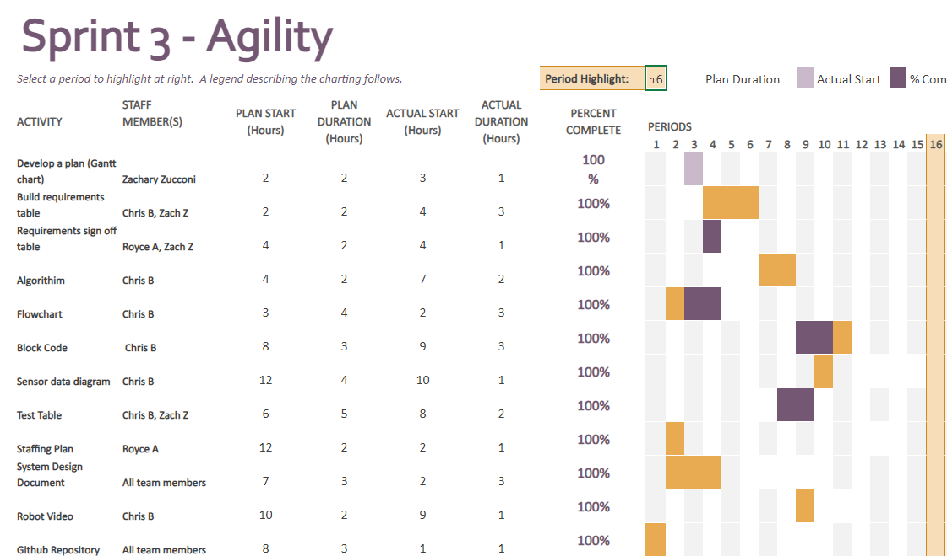

**5.7 Staffing Plan**

| Name | Role | Responsibility | Reports To |
| --- | --- | --- | --- |
| Zachary Zucconi | Assistant | Fill out sections embedded in System Design Document: Test Table, Requirements table etc. | Chris Buzaid |
| Chris Buzaid | Manager | Write the Block Code for robot and sensor data diagram.  Fill out sections embedded in the System Design Document, Test Table, Requirements table, etc. | Chris Buzaid |
| Royce Amburg | Assistant | Fill out sections in System Design document: Agility Design etc. | Chris Buzaid |